Contents

**Background** 1

**GOT Word Clouds** 2

**Most Common Words** 3

**Relative Frequency (GOT1 and GOT2)** 4

**Sentiment Analysis** 5

# **Background**

Input Files:

* Got1.txt - Game of Thrones book 1
* Got2.txt - Game of Thrones book 2

Game of Thrones book files were downloaded from Kaggle

<https://www.kaggle.com/muhammedfathi/game-of-thrones-book-files>

Objectives:

1. Generate a word cloud of the 20 most common words in both files
2. Determine the 1000 most common words for each file and save them into a csv
3. Compare most common words from got1.txt and got2.txt
4. Perform sentiment analysis for each line in got1.txt and got2.txt. Generate a pie chart summarizing the sentiment analysis.

Outputs

* GOT Analysis.ipynb (Python code created using jupyter notebook)
* G1_1000.csv (1000 most common words in GOT 1)
* G2_1000.csv (1000 most common words in GOT2)
* GOT Analysis Summary (this document)

# **GOT Word Clouds**

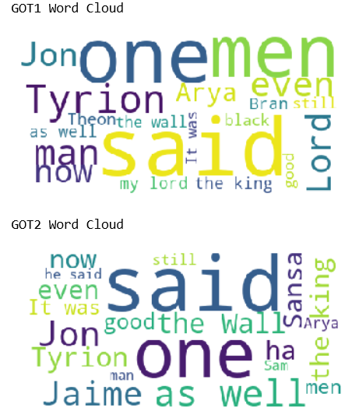

# **Most Common Words**

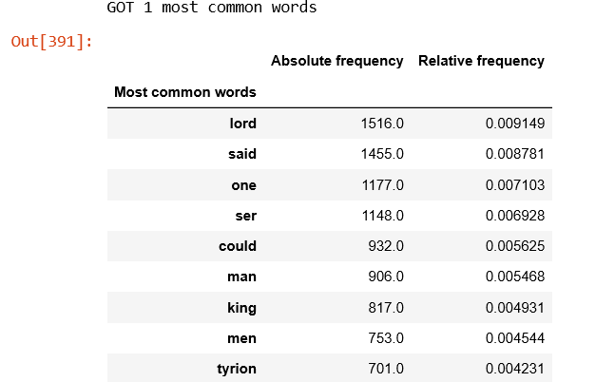

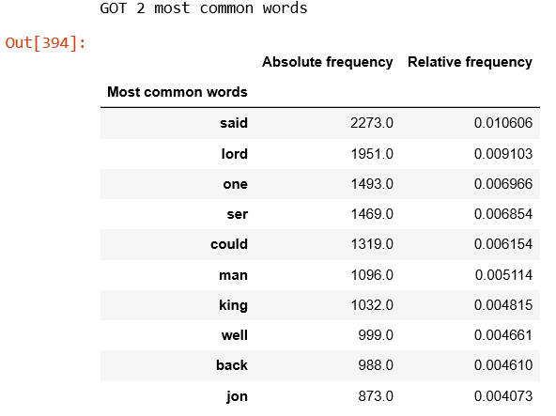

# **Relative Frequency (GOT1 and GOT2)**

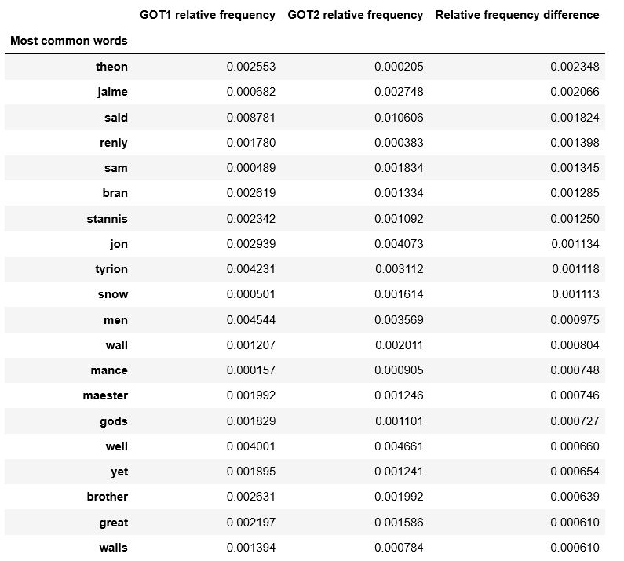

# **Sentiment Analysis**

